**APPENDICES**

**Appendix A Transmittal Letter**

January 11, 2018

Mr. Daniel D. Kaindoy

Owner

Masiwa, Marigondon Lapu-Lapu City, Cebu

Duane and Dwight Enterprise

Dear Mr. Kaindoy

Greetings!

We are the students from the University of San Carlos taking up Bachelor in Science in Information and Communication Technology. We would like to ask permission to conduct a research study in Duane and Dwight Enterprise. The study proposes a delivery tracking system for your enterprise.

The above research study is a requirement for the completion of the degree in Bachelor in Science in Information and Communication Technology in the University of San Carlos. Results from the study shall be kept confidential and will only be used for educational purposes.

Thank you very much. Hoping for your consideration.

Respectfully yours,

Gian Christopher Galicinao Christian Vincent Kaindoy

Rebicca Sarah Manos Christopher John Pepino

Endorsed by: Approved by:

Ms. Angie Ceniza, PhD Mr. Daniel D. Kaindoy

Thesis Adviser Owner of Duane and Dwight Enterprise

**Appendix B Interview Guide**

1. How did Duane and Dwight started?

Duane and Dwight enterprise started its business operation in 2009. Duane and Dwight Enterprise is a supplier of construction materials. Founded by Daniel D. Kaindoy the proprietor of the enterprise.

2. Are there any other branches? Where are these branches located?

Yes, its second branch is located in Soong Mactan, Lapu-Lapu City under the name of Daniel D. Kaindoy’s spouse Arlene I. Kaindoy. The second branch retained its main branch name Duane and Dwight Enterprise Soong Branch.

3. How many years did it took to establish the other branches?

It took us 3 years before the second branch was established which is the Duane and Dwight Enterprise Soong Branch.

4. Why was it named “Duane and Dwight Enterprise”?

Duane and Dwight Enterprises was named after my son Duane Adrian Kaindoy and Dwight Adrian Kaindoy, they are the youngest of the family.

5. What is the current business process of the enterprise

The current business process of Duane and Dwight Enterprise, from first approach down to the delivery of orders are being done manually. Records are done manually, checking is done manually, receiving of order is done manually and so on. Records are being written on a logbook where in it is updated by a clerk from time to time.

6. What problems do you encounter most?

Undelivered orders due to lack of delivery monitoring which usually leads to cancelling of orders and getting the refund back to the customers.

7. How do you handle these problems

Our company handled these problems by adding more personnel to monitor the delivery process and adding more delivery personnel to do the delivery so that we can cater more customers.

8. Have you considered getting automated system?

Yes, for the development/advancement of the whole business process.

9. Do you have automated system in your business? What are these systems and where do you use them?

Yes our company do have existing automated system POS (Point Of Sales) and Cash registry, POS (Point Of sales) intended for inventory and stock management while Cash registry for accounting.

10. What are the disadvantages of your current business process?

Its advantages are inefficient, unorganized, not centralized, unmonitored business process.

11. Would you consider investing for a tracking system? why or why not?

Yes, as an owner of this company I would like to consider investing for a tracking system because it will help you to keep an eye on all the delivery vehicles in the field as well as with the delivery personnel so that they can never lie to you about his location. It also allows me to monitor the speed of the delivery from time to time. Also to ensure that all customer’s order will be served with in the day. Lastly, to offer good quality of delivery service.

**Appendix C Survey Questions**

Dear Respondents,

We are conducting a survey for our capstone project entitled, “H.A.T.OD. (Handling And Tracking of Deliveries) a Delivery Tracking System for Duane and Dwight Enterprise”. The following questions are asked for the researchers would like to know the public’s perception concerning the over-all business process of Duane and Dwight Enterprise, specifically the ordering business process (for the clerk-in-charge), delivery process (for the delivery personnel) and receiving process (for the customers). Please follow the instructions stated, and don’t leave out any item. All data collected will be used for academic purposes only. Your honesty and cooperation is highly appreciated. Thank you.

The Researchers,

________________________ _______________________

Christian Vincent I. Kaindoy Christopher John A. Pepino

________________________ _______________________

Gian Christopher G. Galicinao Rebicca Sarah D. Manos

CLERK-IN-CHARGE

Please encircle the letter of your desired answer.

**1. How many transactions do you do in a day?**

a. 5-10 b.11-15 c. 16-20 d. 20-25

e. Others (please specify) _____

**2. Do you make a transaction to a customer manually? (Ex: by writing)**

a. Yes b. No

**3. Does it take you a lot of time to manually write the transaction or order?**

a. Yes b. No

**4. How do you keep all the transactions you made?**

a. through a log book b. by compiling all receipts

c. Others (please specify) _____________

**5. Do you agree to have an automated system that can take orders?**

a. Yes b. No

**6. Would you consider an automated system with a feature that can help you sort all the transactions you had made?**

a. Yes b. No

DELIVERY PERSONNEL

Please encircle the letter of your desired answer.

**1. How many deliveries do you do in a day?**

a. 5-10 b.11-15 c. 16-20 d. 20-25

e. Others (please specify) _____

**2. Have you encountered problems in locating a customer’s address?**

a. Yes b. No

**3. If yes, how do you address your problem? (If you answered No on the previous question please disregard this question and proceed to number 4).**

a. Ask around to know the location

b. Ask another delivery personnel to do the delivery

c. Others (please specify) ___________

**4. In delivering multiple orders do you arrive on the customers’ location on time as the schedule of deliveries?**

a. Yes b. Sometimes c. No

**5. Would you consider an automated system with a feature that can help in locating a customer’s address?**

a. Yes b. No

**Appendix D Forms**

**Appendix E Software Requirements Specifications**

**Admin’s Module**

ADMIN’S ORDERS LIST

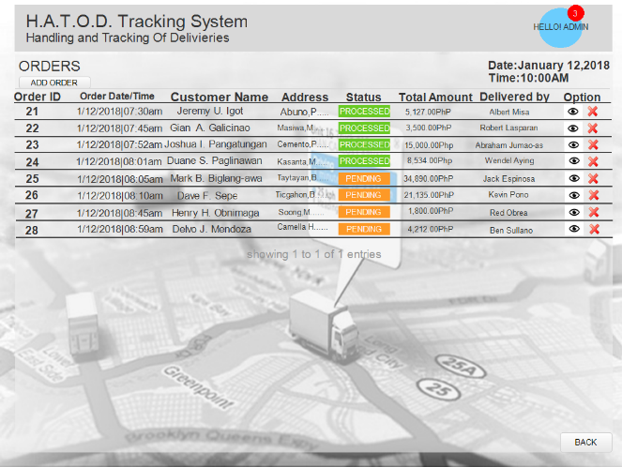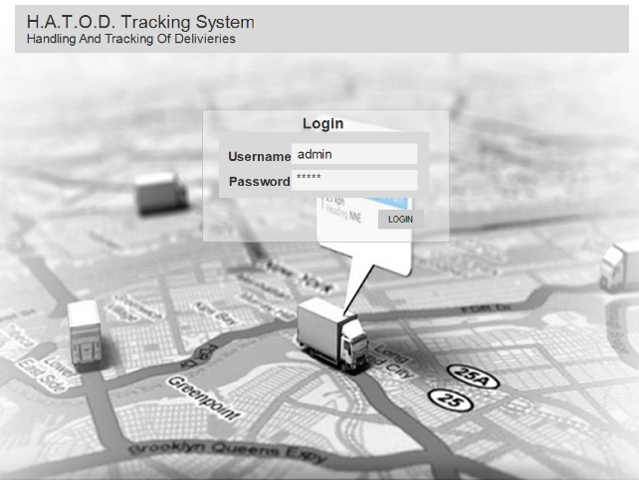ADMIN’S LOGIN PAGE

**3**

In order’s list this displays the transactions and its corresponding status.

**1**

VIEW ORDER’S DETAILS

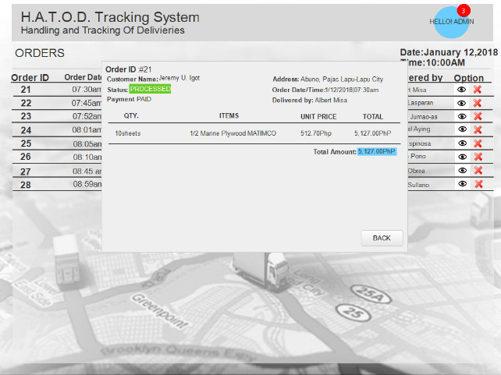Admin inputs username and password

to login.

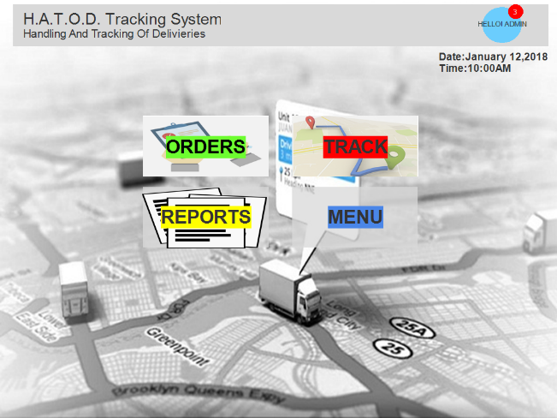ADMIN’S DASHBOARD

**4**

The details of the order it is shown on this pop-up page, it contains the items and total.

**2**

Dashboard is the landing page after

logging in.

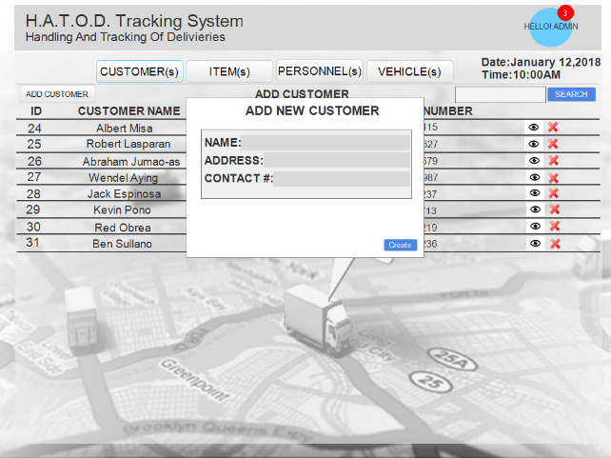

ADMIN CREATES NEW CUSTOMER

ADMIN’S CREATE/ADD NEW ORDER PAGE

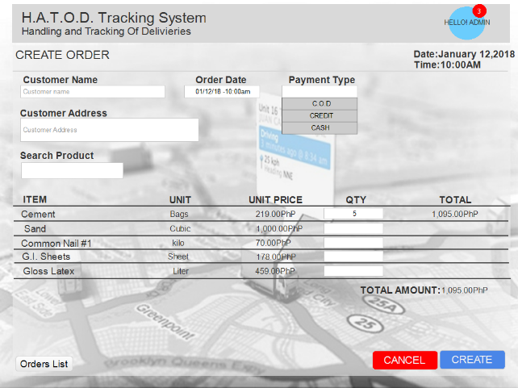

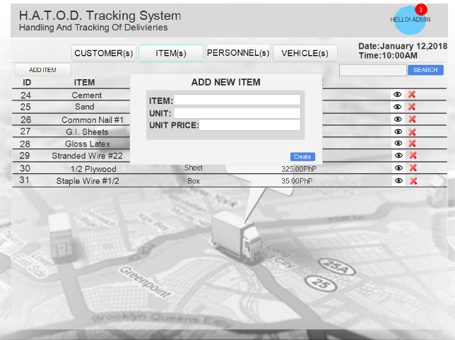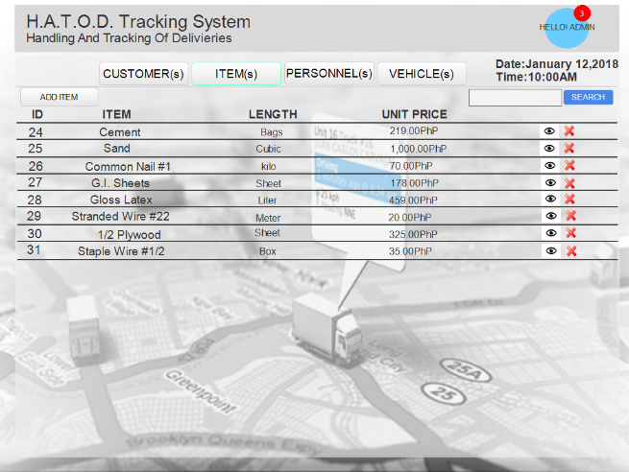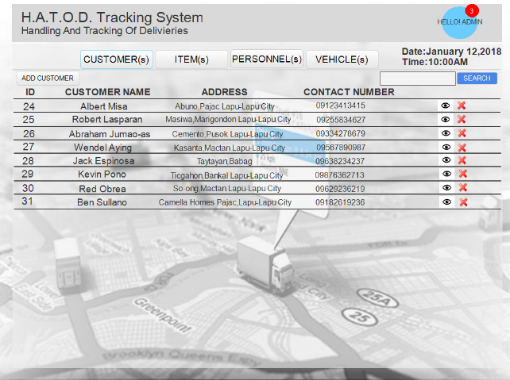

In creating a new item, admin inputs the item name, unit of measurement and unit per price.

**9**

CREATING NEW ITEM

This contains all the items, the unit for each item and its price.

**8**

ITEMS LIST

To create a customer, the admin inputs customer’s details; name, address and contact number.

**7**

**5**

The customers’ list contains the costumer’s name, address and contact number.

**6**

ADMIN’S VIEW CUSTOMER LIST

To create a new order, the admin inputs customer’s details, select a date for the delivery and the items the customer wants.

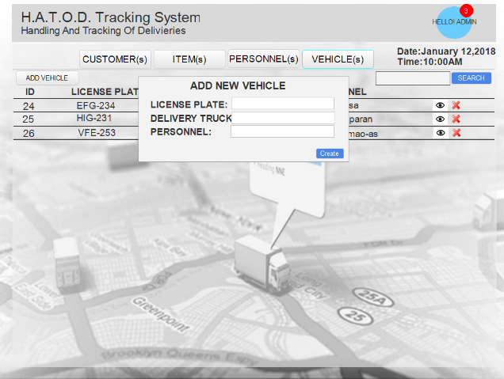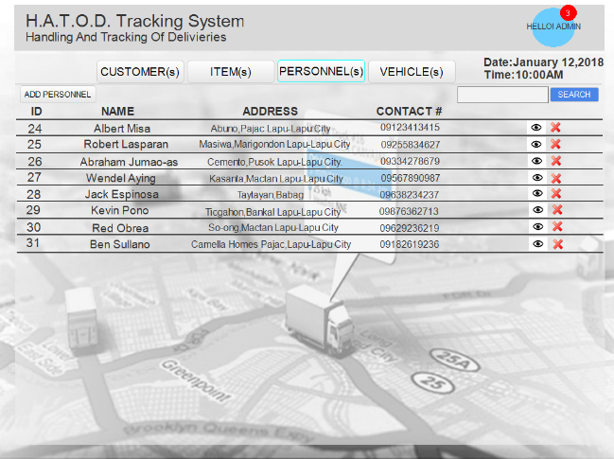

CREATING NEW VEHICLES

PERSONNEL LIST (Includes clerks-in-charge and delivery personnel)

To add a new vehicle, admin inputs the vehicle’s license plate, vehicle type and the personnel assigned to it.

**13**

The personnel list contains all the records of the clerk-in-charge and of the delivery personnel.

**10**

TRACKING OF DELIVERY VEHICLE

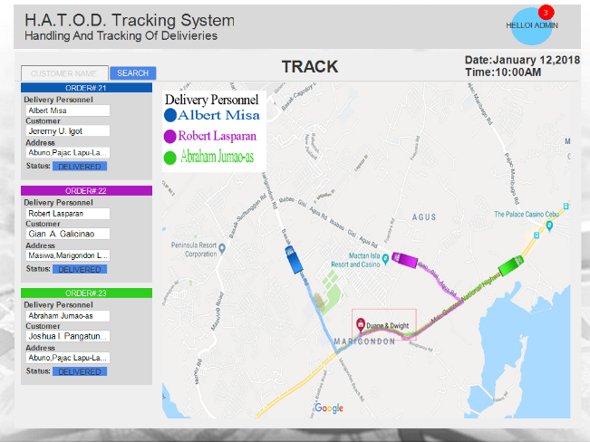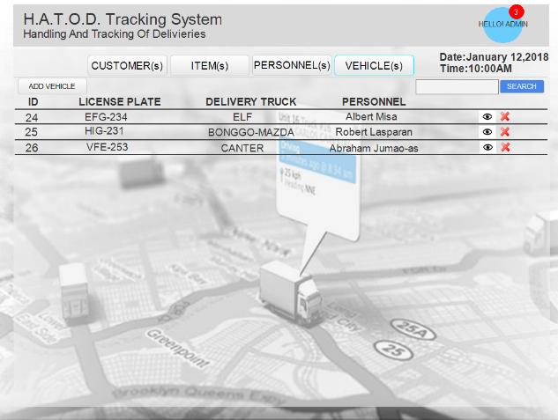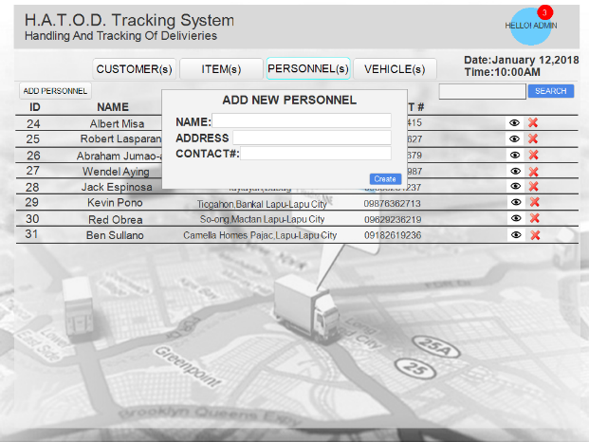

The tracking page contains, the order number with details of the delivery personnel, customer’s name and address. It also shows the real-time location of the delivery vehicles.

**14**

The vehicles’ list page contains all details for a vehicle, it’s license plate, vehicle type and the personnel assigned.

**12**

VEHICLE LIST

In adding a new personnel, admin inputs the personnel’s name, address and contact num.

**11**

ADDING NEW PERSONNEL PAGE

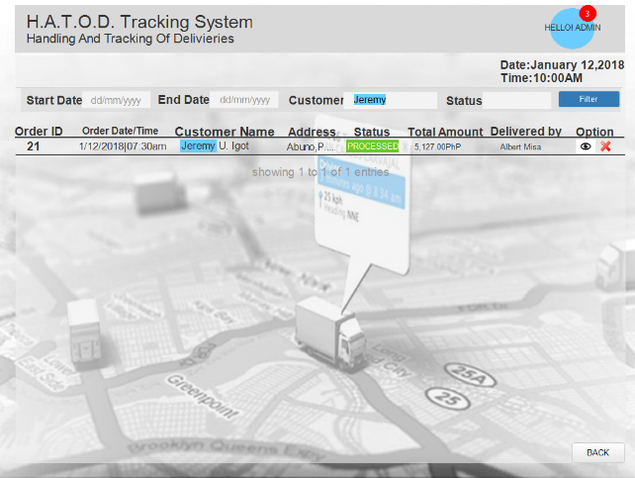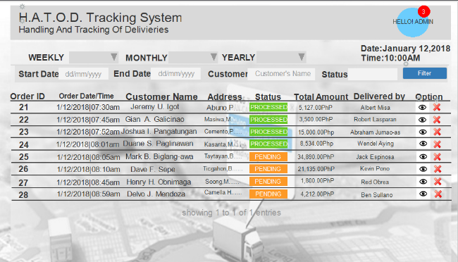

FILTERING FUNCTION FOR REPORTS

SUMMARY OF REPORTS

The system can filter searches by the use of a range of dates.

The system can generate a summary of the reports for a daily, weekly, monthly or yearly basis. It also shows the status of the transactions.

**16**

**15**

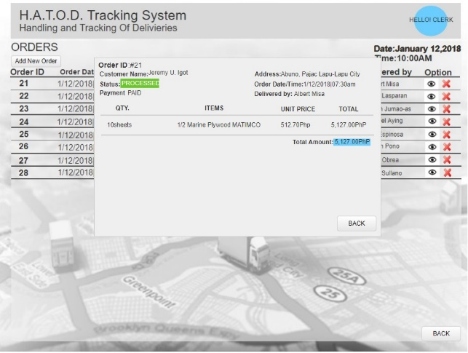**CLERK-IN CHARGE’S MODULE**

VIEW ORDER DETAILS

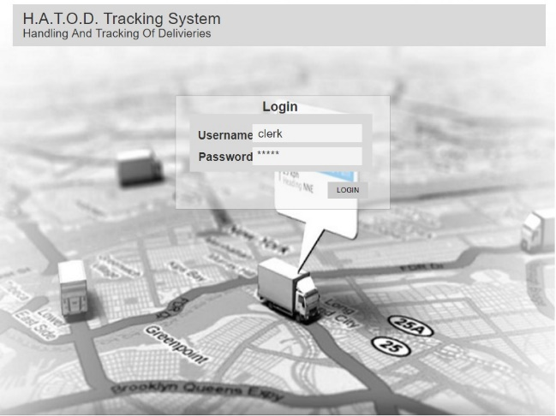LOGIN PAGE

**1**

**4**

The details of the order it is shown on this pop-up page, it contains the items and total.

Clerk inputs username and password to

LIST OF CUSTOMERS

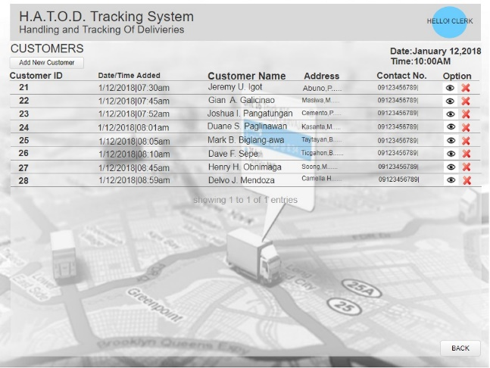login.

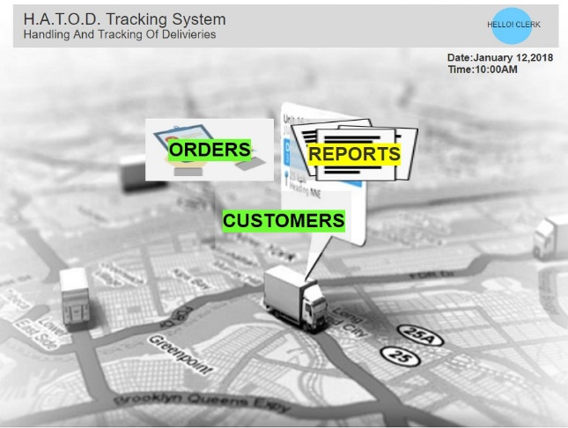CLERK’S DASHBOARD

This page contains the list of all the customers. Name, address and contact number is displayed on this page

**5**

**2**

VIEW CUSTOMER’S DETAILS

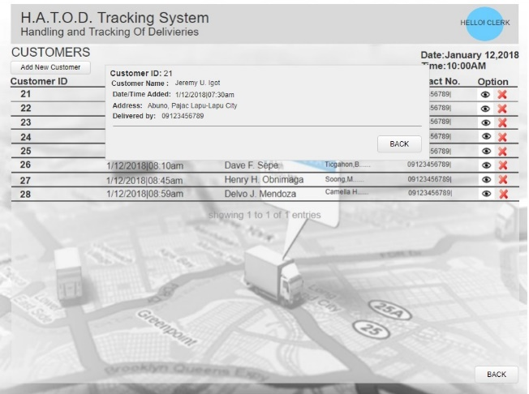

Dashboard is the landing page after

logging in.

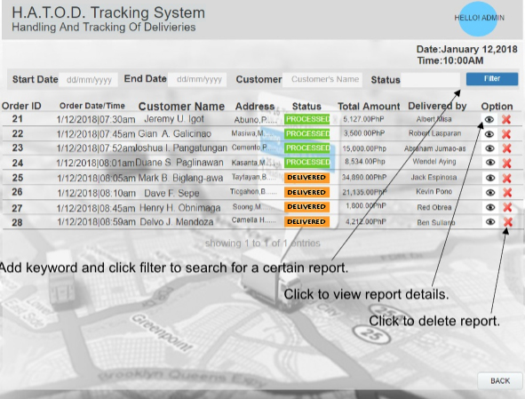REPORTS OF ORDER’S PAGE

In order’s list this displays the transactions and its corresponding status.

**3**

The details of the customer is shown on this pop-up page.

**6**

**DELIVERY PERSONNEL MODULE**

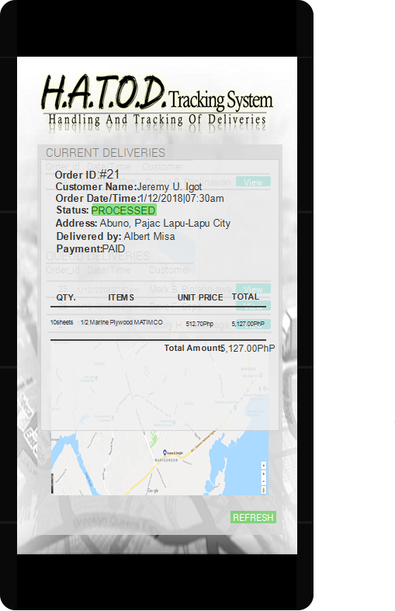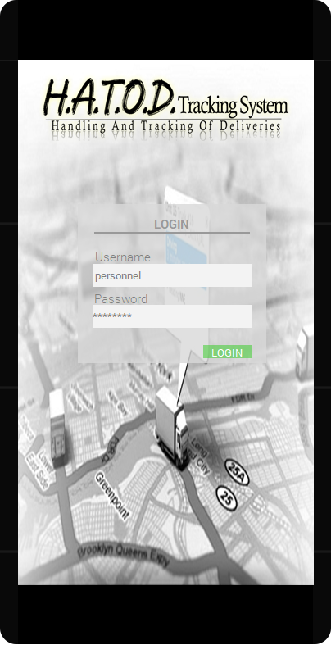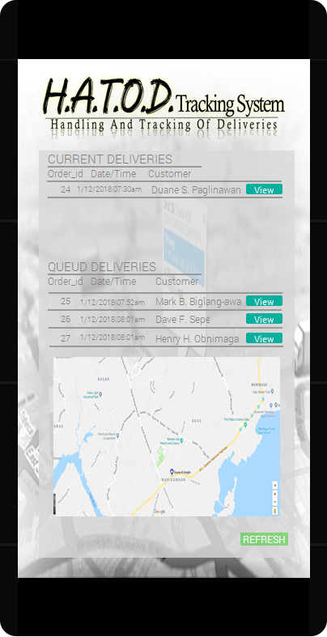

**3**

**2**

**1**

DELIVERY LIST DETAILS OF ORDER/DELIVERY

DELIVERY LIST

LOGIN PAGE

**Appendix F Functional Requirements**

**HATOD (Handling And Tracking Of Deliveries): A delivery tracking system for Duane and Dwight Enterprise with SMS Notification**

**Functional Requirements**

Gian Christopher G. Galicinao

Christian Vincent I. Kaindoy

Rebicca Sarah D. Manos

Christopher John A. Pepino

Approved by:

_______________________________

Ms. Mary Jane Sabellano (Chair of the Panel)

_______________________________

Ms. Angie Ceniza (Adviser)

|  |  |
| --- | --- |
| **Module Name** | **Functionality** |
| **ADMIN MODULE** |  |
| CREATE Module | It enables the admin to add (as well as delete) personnel, products, vehicles, customers and orders. |
| REPORTS Module | It enables the admin to generate a summary of all the transactions that was made daily, weekly, monthly and yearly. |
| TRACK Module | It enables the admin to track a vehicle in-real time. |
| SMS NOTIFICATION Module | It enables the system to send an SMS notification to a customer about his/her delivery status. |
| PROFILE Module | Organizes the information of the admin. |
| **CLERK MODULE** |  |
| CREATE Module | It enables the clerk to add a customer and order. |
| REPORTS Module | It enables the clerk to generate a summary of all the transactions that was made daily, weekly, monthly and yearly. |
| PROFILE Module | Organizes the information of the admin. |
| **DELIVERY PERSONNEL MODULE** |  |
| TRACK Module | It enables the delivery personnel to be tracked in-real time. |
| PROFILE Module | Organizes the information of the admin. |
| **CUSTOMER MODULE** |  |
| SMS NOTIFICATION Module | It enables the system to send an SMS notification to a customer about his/her delivery status. |
| PROFILE Module | Organizes the information of the customer. |

**Appendix G Black Box Testing**

**Appendix H User Acceptance Testing**

**HATOD (Handling And Tracking Of Deliveries): A delivery tracking system for Duane and Dwight Enterprise with SMS Notification**

**User Evaluation and Testing Form**

By:

Gian Christopher G. Galicinao

Christian Vincent I. Kaindoy

Rebicca Sarah D. Manos

Christopher John A. Pepino

Please put a check (√) mark on the rating boxes.

|  |  |  |  |  |  |  |
| --- | --- | --- | --- | --- | --- | --- |
| Criteria | Description | Rating (1 – Lowest / 5 – Highest ) | | | | |
|  | | 1 | 2 | 3 | 4 | 5 |
| 1. Functionality |  |  |  |  |  |  |
| 1.1 Accuracy | How does the system adequately meet its objectives? |  |  |  |  |  |
| 1.2 Security | How protected is the system and its data contents from unauthorized access? |  |  |  |  |  |
| 2. Reliability |  |  |  |  |  |  |
| 2.1 Data Validity | Does the system check and validate user input to avoid erroneous data entry? |  |  |  |  |  |
| 2.2 Recoverability | How easily does the system provide a way to back-up data stored in it? |  |  |  |  |  |
| 3. Usability |  |  |  |  |  |  |
| 3.1 Understandability | Does the system provide on-screen instructions? |  |  |  |  |  |
| 3.2 Learnability | Can users quickly and easily learn to use the software? |  |  |  |  |  |
| 3.3 Operability | Can users easily navigate between program screens? |  |  |  |  |  |
| 3.4 Attractiveness | Is the overall user interface visually pleasing? |  |  |  |  |  |
| 4. Efficiency |  |  |  |  |  |  |
| 4.1 Ease of Start-up | How easily is the system started up? |  |  |  |  |  |
| 4.2 Resource Utilization | Does the system require minimal hardware resources? |  |  |  |  |  |
| 4.3 Time Behaviour | How quickly does the system accomplish specific actions? |  |  |  |  |  |

|  |  |  |  |  |  |  |
| --- | --- | --- | --- | --- | --- | --- |
| Criteria | Description | Rating (1 – Worst / 5 – Best ) | | | | |
|  | | 1 | 2 | 3 | 4 | 5 |
| 5. Maintainability |  |  |  |  |  |  |
| 5.1 Installability | How easily is the system installed (in case re-installation is needed)? |  |  |  |  |  |
| 5.2 Testability | Can the system be tested and verified using test/sample data? |  |  |  |  |  |
| 6. Support and Manuals |  |  |  |  |  |  |
| 6.1 Understandability | Does the user manual provide clear and concise instructions on how to operate the software? |  |  |  |  |  |
| 6.2 Visual References | Does the user manual provide actual screenshots showing how to operate the software? |  |  |  |  |  |

|  |  |
| --- | --- |
| Comments/Suggestions | |
| 1. Functionality |  |
| 2. Reliability |  |
| 3. Usability |  |

|  |  |
| --- | --- |
| Comments/Suggestions | |
| 4. Efficiency |  |
| 5. Maintainability |  |
| 6. Support and Manuals |  |

Table Summary

|  |  |
| --- | --- |
| Criteria | Total Score |
| 1. Functionality | Total score ÷ no. of sub-questions |
| 2. Reliability | Total score ÷ no. of sub-questions |
| 3. Usability | Total score ÷ no. of sub-questions |
| 4. Efficiency | Total score ÷ no. of sub-questions |
| 5. Maintainability | Total score ÷ no. of sub-questions |
| 6. Support and Manuals | Total score ÷ no. of sub-questions |

Average Score Interpretation:

4.1 – 5.0 = Very Acceptable

3.1 – 4.0 = Acceptable

2.1 – 3.0 = Moderately Acceptable

1.0 – 2.0 = Not Acceptable

Average Score: <insert the average of all total scores, then use the range interpretations to determine acceptability>

Evaluated and Tested by:

_______________________________

<signature over name of company representative>